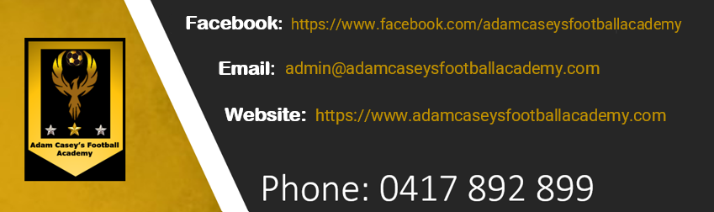

SAFEGUARDING

ACFA and its affiliated Football Entities aims to provide a safe and enjoyable environment for all Members participating in football. Everyone involved in our sport should be treated with respect and dignity and be free to participate without being discriminated against, harassed, bullied or abused.
All Children and Adults at Risk should be able to enjoy participating in football in a safe, supportive and empowering environment. Football Entities recognise that it is the responsibility of every Member to safeguard the welfare and wellbeing of all Children and Adults at Risk and Football Entities aim to ensure that our sport has an environment where everyone is empowered to protect themselves and one another.
All Members, in particular a Child or Adult at Risk, should feel comfortable, and be encouraged to, speak up and report any concerns they may have or be aware of in relation to the safeguarding of Children and Adults at Risk in football.
The Governing Bodies acknowledge that staff, members and volunteers provide a valuable contribution to the experiences of Children and Adults at Risk involved in football. The Governing Bodies aim to continue this and to take measures to protect the safety and wellbeing of all Children and Adults at Risk participating in football.

Member Protection Information Officers
A Member Protection Information Officer (MPIO) is generally the first point of contact for persons with member protection or child protection enquiries or complaints. MPIOs provide information to participants about the options available to them. MPIOs can also provide information to clubs about member protection and related issues and policies. MPIO’s are impartial and generally do not mediate or investigate complaints.
Depending on what level your matter relates to, will affect which MPIO you should contact. Generally, if your concern relates to behaviour or an incident which occurred at the:
- Club level or involves people operating at the club level, then the complaint should be reported to and handled by the relevant Club in the first instance.
- State level or involves people operating at the relevant state level, then the complaint should be reported to and handled by the relevant Member Federation in the first instance; and
- National level, then the complaint should be reported to and handled by Football Australia.
Further, only the most serious cases from state level should be referred to Football Australia.
If you are having any difficulty finding the contact details of your Club’s or Association’s MPIO, you should contact your relevant Member Federation.

Working With Children Checks
Working with Children Checks aim to create a child-safe environment and to protect children and young people involved in our sport from physical and sexual harm.
They assess the suitability of people to work with children and young people and can involve:
- criminal history checks;
- signed declarations;
- referee checks; and
- other relevant background checks to assess a person’s suitability to work with children and young people.
Detailed information, including the forms required to complete a Working with Children Check, are available from the relevant agencies in each state and territory.

Child Protection and Procedures for Handling Allegations of Child Abuse
ACFA98 Safeguarding Policy provides details as to procedures which should apply in instances of allegations of Child Abuse.
Further, child protection legislation imposes obligations on organisations and participants in relation to reporting and screening processes.
Currently, there is no national legislation and child protection system. However, each state and territory has child protection laws specifying responsibilities for both organisations and individuals who work or have contact with children.
Fact sheets on child protection and reporting allegations of child abuse in different states and territories are available at www.playbytherules.net.au

If you believe a child is in immediate danger or a life-threatening situation, you should contact the Police immediately.
Contact details for advice or to report an allegation of child abuse are:

New South Wales | New South Wales Police  Non-urgent police assistance  Ph: 131 444  Department of Family and Community Services  Ph: 132 111

